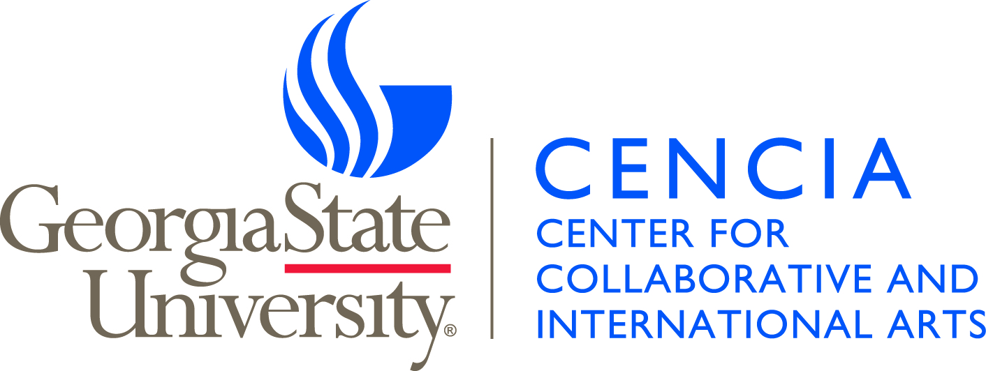

2017-2018 CENCIA Project Proposals

Due February 15, 2017
Awards announced March 2017

GENERAL INSTRUCTIONS:

In 2017-2018, CENCIA will be a significant participant in Georgia State University’s “YEAR OF THE ARTS.” This special observance will celebrate the formation of the new College of the Arts within the University, highlight the world-class work being accomplished by the vibrant and diverse College of the Arts faculty, provide meaningful opportunities and interactions for students, and demonstrate Georgia State’s commitment to and promotion of the Arts as a vital component to society.

Given the special nature of the 2017-2018 CENCIA season and its integration into the “YEAR OF THE ARTS” celebration, this Request for Proposals is different than in past funding cycles. For 2017-2018, CENCIA is seeking three (3) major project proposals. These proposals will be submitted in the following manner: one project proposal will originate from each of the respective main units of the newly formed College of the Arts: the Ernest G. Welch School of Art & Design, the Film, Media and Theatre area, and the School of Music. Each selected project may be awarded up to $15,000.00 in funding support. Each unit will be responsible for evaluating proposals from its respective faculty members. The process for evaluation is to be determined by the Directors of each respective unit. Once evaluations of proposals have been concluded, the Directors of each of the units will recommend their respective project to the CENCIA Executive Committee. While the three selected projects described above will serve as the major events associated with the “YEAR OF THE ARTS,” CENCIA will also consider “SPOTLIGHT ON THE ARTS” projects which may receive up to $1000.00 in funding support pending budgetary constraints. These more modestly funded projects will be evaluated by the CENCIA Executive Committee and the Director of CENCIA.

All full-time regular faculty of the College of the Arts at Georgia State University are eligible to apply. College of the Arts faculty may also include faculty outside the College (whether in other colleges or outside the University) in a project proposal. However, all project proposals must originate from within the College of the Arts.

Applicants may use this Microsoft Word document for the proposal or create a new document with sections A through I appropriately labeled. Please do not omit any section. Responses should be limited to one page unless otherwise noted. Applicants should refer to the CENCIA Project Proposal Guidelines for assistance in completing the proposal. The guidelines can be found at cencia.gsu.edu. If further assistance is required, please feel free to contact Nickitas Demos, CENCIA Director (ndemos@gsu.edu) and/or Annie Latta, CENCIA Program Manager (alatta@gsu.edu).

For the “YEAR OF THE ARTS” proposals, application forms are due to the Directors of the Ernest G. Welch School of Art & Design, the Film, Media and Theatre area and the School of Music from faculty within those units respectively no later than February 15, 2017. Final proposals should be submitted via email to the respective directors and copied to Annie Latta. For the “SPOTLIGHT ON THE ARTS” proposals, application forms are due to Annie Latta on the same date: February 15, 2017.

Applicants are required to discuss their proposal with both their directors and their business managers prior to submission. School business managers will facilitate all financial aspects of projects including travel arrangements, honoraria, and other related expenses.

2017-2018 CENCIA Project Proposal for
GEORGIA STATE UNIVERSITY “YEAR OF THE ARTS” CELEBRATION

Applicant Name: _______________________________________________________________

Project Title: _______________________________________________________________

School : _______________________________________________________________

Email: __________________________________ Phone: ______________________

Signature: ___________________________________________ Date: _______________
I certify that the information contained within is complete and accurate to the best of my knowledge.

Director of the School

Name: ________________________________________________________________

Signature: ___________________________________________ Date: _______________
I certify that I have reviewed and approve this project proposal and budget.

School Business Manager

Name: _________________________________________________________________

Signature: ____________________________________________ Date: _______________
I certify that I have reviewed and approve this project proposal and budget.
2017-2018 CENCIA Project Proposal

- PROJECT DESCRIPTION

CENCIA provides meaningful opportunities for artists of diverse disciplines to collaborate and connect with local, national and international communities through accessible arts programming. Through its energetic promotion of the Arts, CENCIA asserts the College of the Arts at Georgia State University as a significant international center for artistic expression. Please indicate whether you are applying for a “YEAR OF THE ARTS” project or a “SPOTLIGHT ON THE ARTS” project and describe how your proposed project fulfills the CENCIA mission. As CENCIA is a research center within the University, please also take into consideration such matters as major project activities, schedule, key participants, opportunities for student involvement, alignment with teaching and/or research goals, and research and teaching outcomes. While specificity is important, please limit your description to one page.

Check one of the options below:

 | YEAR OF THE ARTS PROJECT  Award up to $15,000.00 |  | SPOTLIGHT ON THE ARTS PROJECT  Award up to $1,000.00

2017-2018 CENCIA Project Proposal

- LEVEL OF INTERDISCIPLINARY AND/OR INTERNATIONAL COLLABORATION

Please briefly describe the interdisciplinary and/or international collaboration components the proposed project. Clearly indicate that all collaborators have agreed to participate on the specified dates through inclusion of email(s), letter(s), or other evidence of their agreement as attachments with this proposal.

- AUDIENCE

Please describe the intended audience, both internal and external, for your program. The high potential for a large audience size will be an important factor in a successful proposal. Describe how the project facilitates the inclusion of students in the audience through workshops, master classes, etc. Describe how this project may connect with international student and/or community groups.

- DATE(S) OF PROJECT

Please provide two (2) proposed and ranked dates for the project. These dates should be vetted with both the artist(s) and venue(s) to confirm availability. Please include confirmation of participation by all (including venue) involved in the project as attachments with this proposal.

FIRST CHOICE | SECOND CHOICE
DATE(S): | DATE(S):
TIME(S): | TIME(S):
VENUE(S): | VENUE(S):
2017-2018 CENCIA Project Proposal

- VENUE

In keeping with CENCIA’s mission to position the College of the Arts at Georgia State University as a significant international center for artistic expression, projects should, ideally, take place on campus. However, off-campus venues may be considered. Projects may also utilize a combination of both on-campus and off-campus venues for different components such as workshops, master classes, exhibitions, etc. If the project (or components of the project) will take place off-campus, please briefly explain how the use of any off-campus venues is beneficial to the project, how it will broaden the project’s audience, and how it still ties to CENCIA and the College of the Arts at Georgia State University.

Proposals should indicate that all proposed venues are available and reserved for your project on the proposed dates, as indicated in Section D. Please also include an estimated price quote from venues if necessary, including any additional costs for items such as audio/visual recording, lighting, rentals, other technical requirements, rehearsal space/time, security, etc. Letters or emails attesting to the venue’s availability and costs should be submitted as attachments with this proposal.

- TRAVEL AND LOGISTICS

Please indicate clearly who will be traveling and from where. Estimate cost of airfare based on economy class. Estimate hotel at $125 per night. Estimate meals at $51 per day. Estimate miscellaneous costs such as parking ($7 per day) and local transportation if needed.

2017-2018 CENCIA Project Proposal

- EXTERNAL FUNDING

CENCIA projects are funded in two ways:
- Full funding from CENCIA
- Partial funding from CENCIA and partial funding from additional internal and/or external sources

Additional internal funding sources may include (but are not limited to):
- School funds
- Student organization funds
- Endowed lecture funds
- College or university level funds
- In-kind support in the form of venue space, equipment use, student assistants, etc.

Additional external funding sources include (but are not limited to):
- Foundations
- Local arts organizations
- Local, state, or federal granting agencies
- Other arts granting agencies
- In-kind support in the form of venue space, equipment use, marketing, etc.

Please enumerate all potential external funding sources and indicate if the support is confirmed, applied for, or identified to be pursued. Describe any ways in which a project will be altered if external funding is not obtained. All applications for external funding should go through proper channels in the College and the University. For more information, please contact the College of the Arts Administrative Officer, Crystal Maddox (cbarron1@gsu.edu).

2017-2018 CENCIA Project Proposal

- BUDGET

CENCIA award dollars are state funds and as such fall under state guidelines regarding usage. Food may only be purchased if it is to provide guest meals during their stay working on the project. Both food purchases and guest meals are reimbursed up to $51 per day with receipts. Travel expenses and honorarium for each guest should be listed as separate line items clearly indicating the name of the artist.

Persons already employed full-time by GSU and/or the BOR are not generally eligible for honoraria. Part-time employees’ participation should be reviewed with School business managers for eligibility for honoraria prior to submission of the proposal. Graduate and/or undergraduate student assistants can be used for program-related administrative or research purposes. Student eligibility should be reviewed with School business managers.

Pending budgetary constraints, CENCIA may use CENCIA Foundation funds for receptions for the audience and visiting artists for selected projects. School Foundation funds and student group funds are also a source of funding for receptions. Do NOT include these funds in the budget worksheet, however, as they are not state funds.

- Previous CENCIA Awards

If you have received previous funding from CENCIA, please identify the name of the project, the amount funded, and the year awarded.

2017-2018 CENCIA BUDGET WORKSHEET

